**Wei Liang** **SP17**

**CST 2309-E286**

**Lab#10**

**Prof. Sancar Avcioglu March 20, 2017**

**Lab10**

**Question 1:**

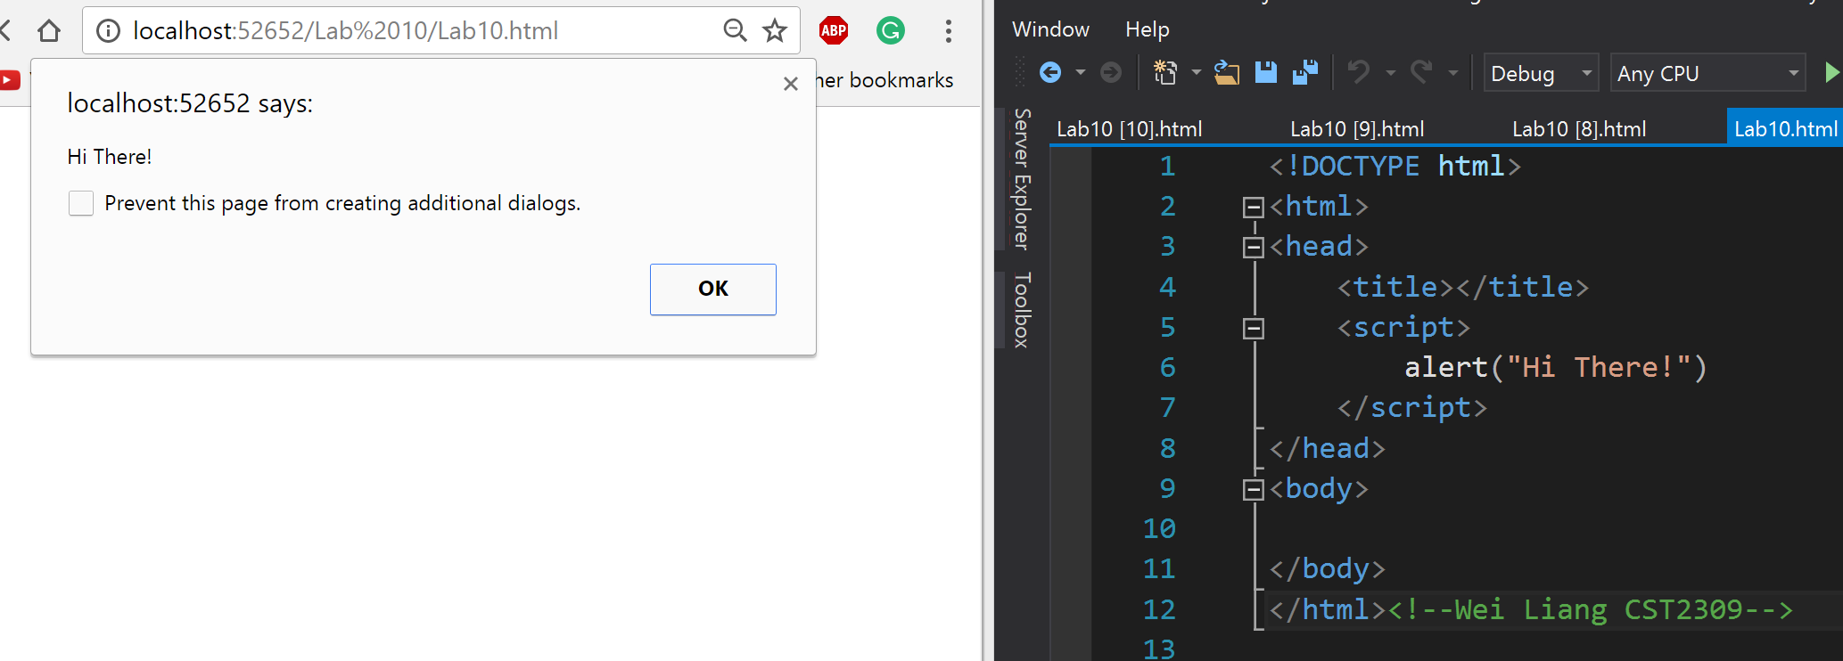

**Question 2:**

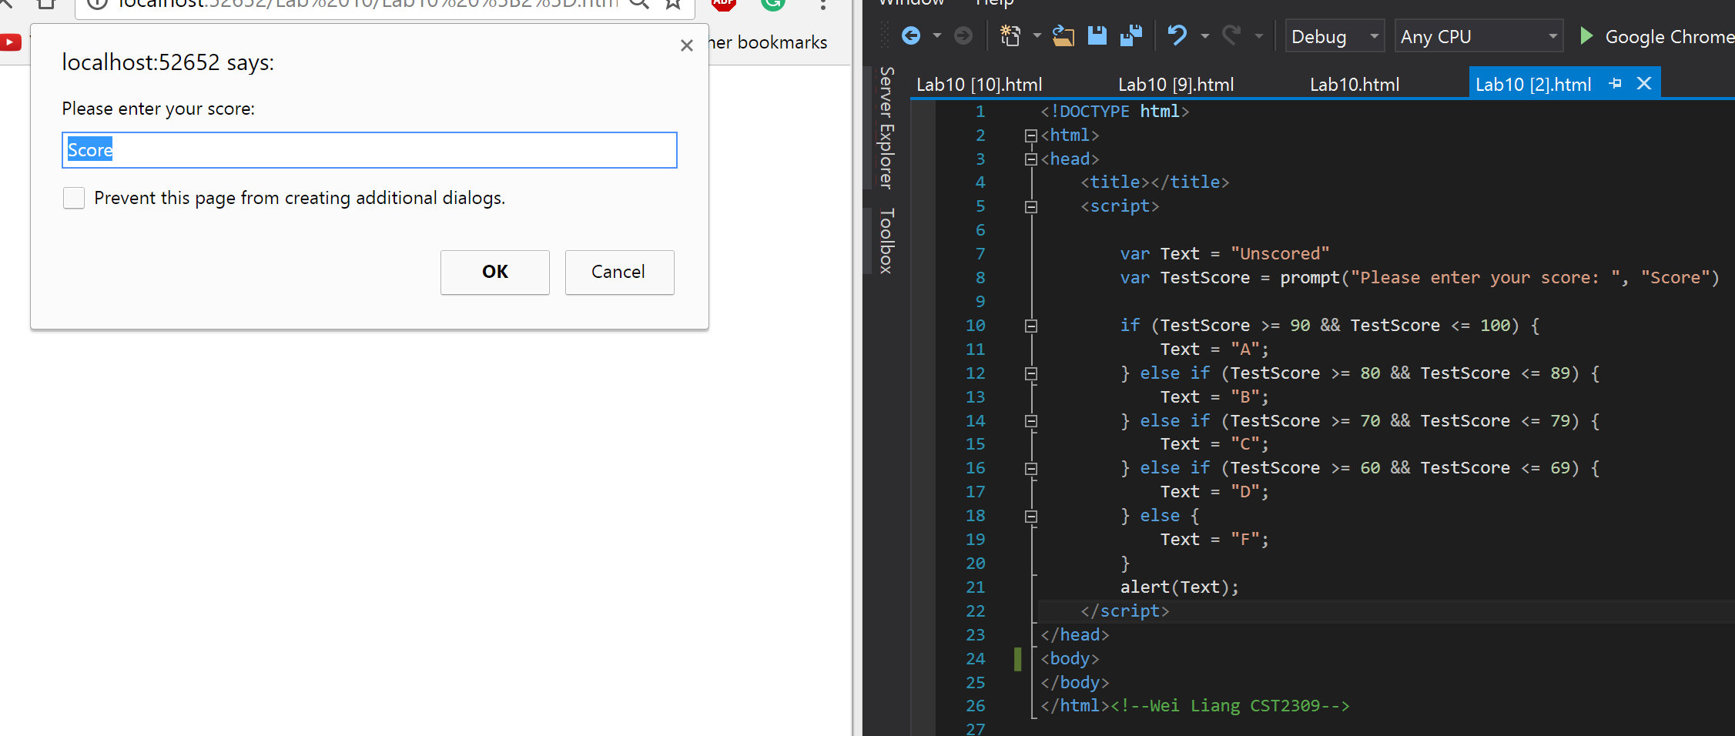

|  |  |  |  |  |
| --- | --- | --- | --- | --- |
| **Input 90 Results:** | **Input 82 Results:** | **Input 72 Results:** | **Input 62 Results:** | **Input 55 Results:** |

**Question 3:**

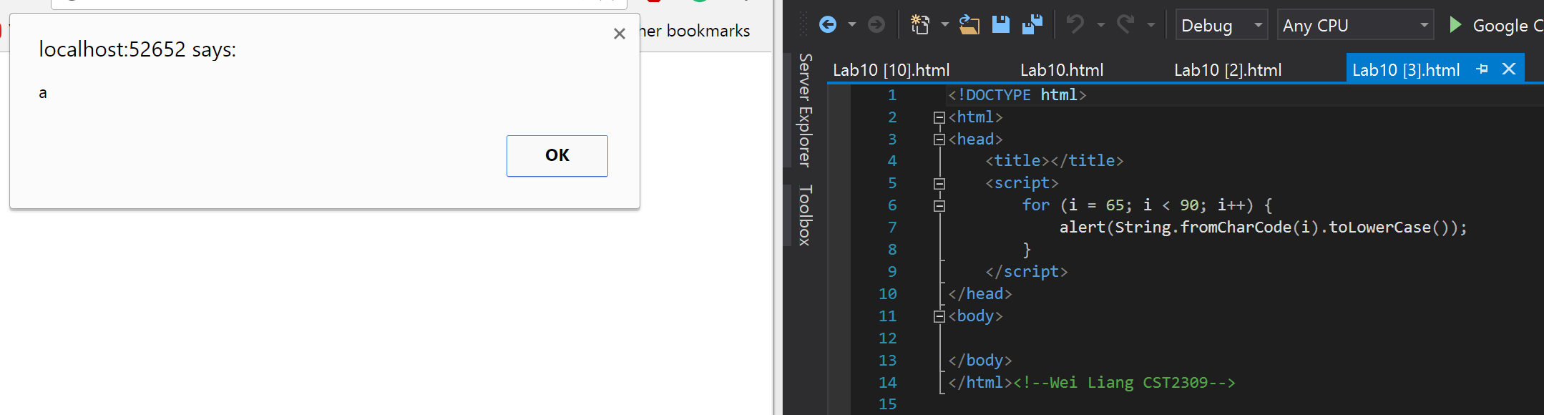

|  |  |  |  |  |  |
| --- | --- | --- | --- | --- | --- |
|  |  |  |  |  |  |

**[Yeah… I’m not going Snip all the in-between alphabets]**

**Question 4:**

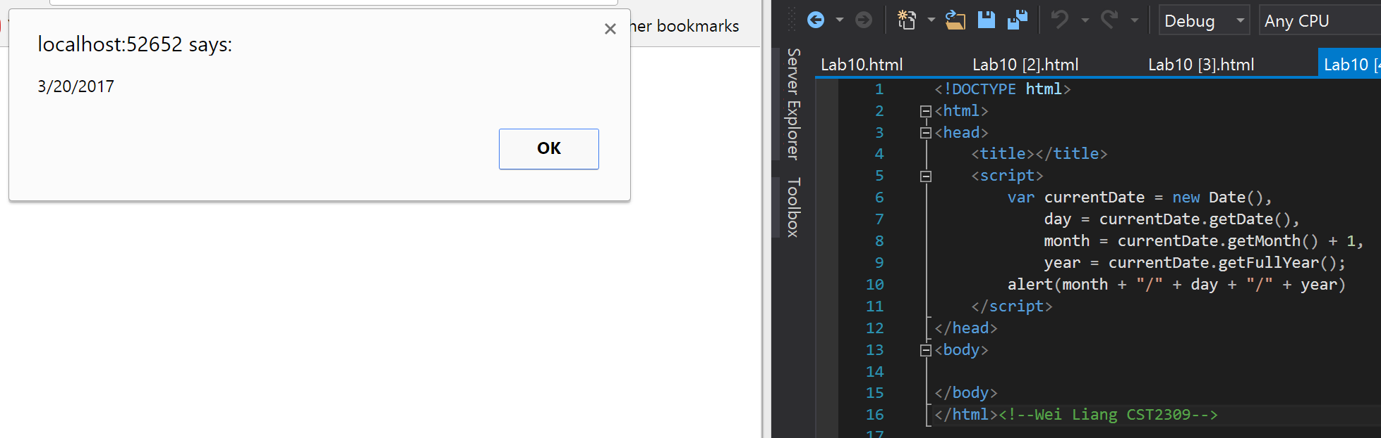

**Question 5:**

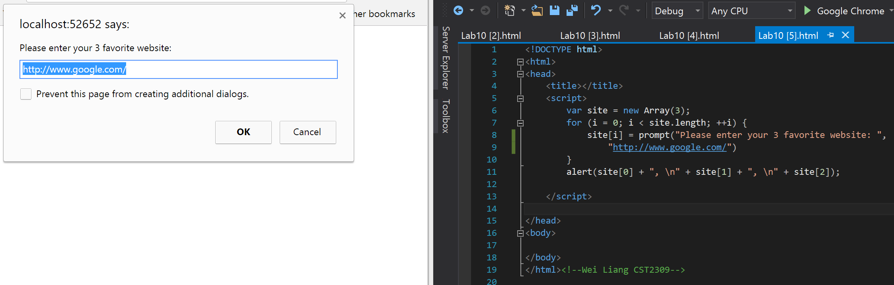

**Inputted 10minutemail, fakenamegenerator, and hackertyper . Results:**

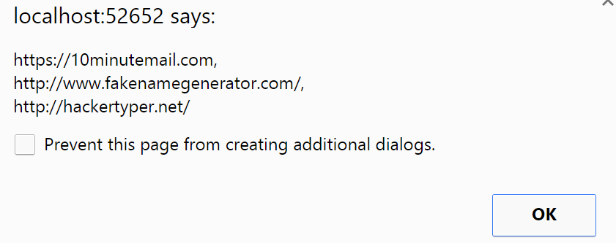

**Question 6:**

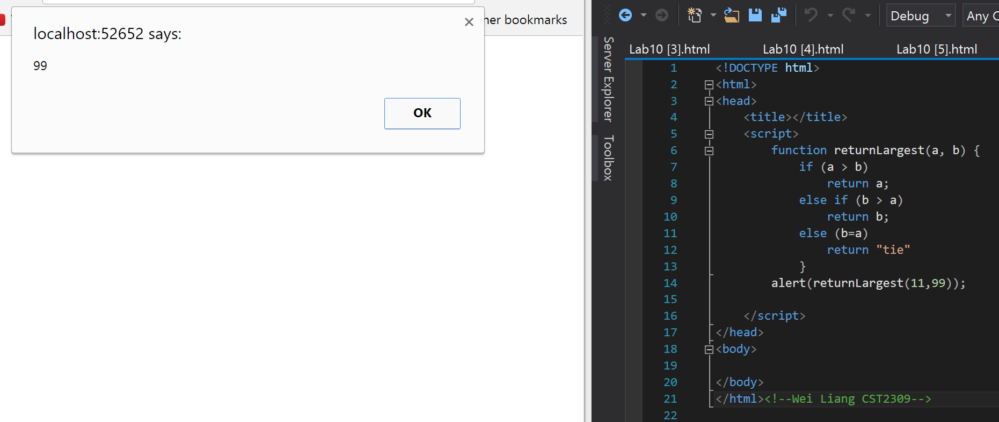

**Question 7:**

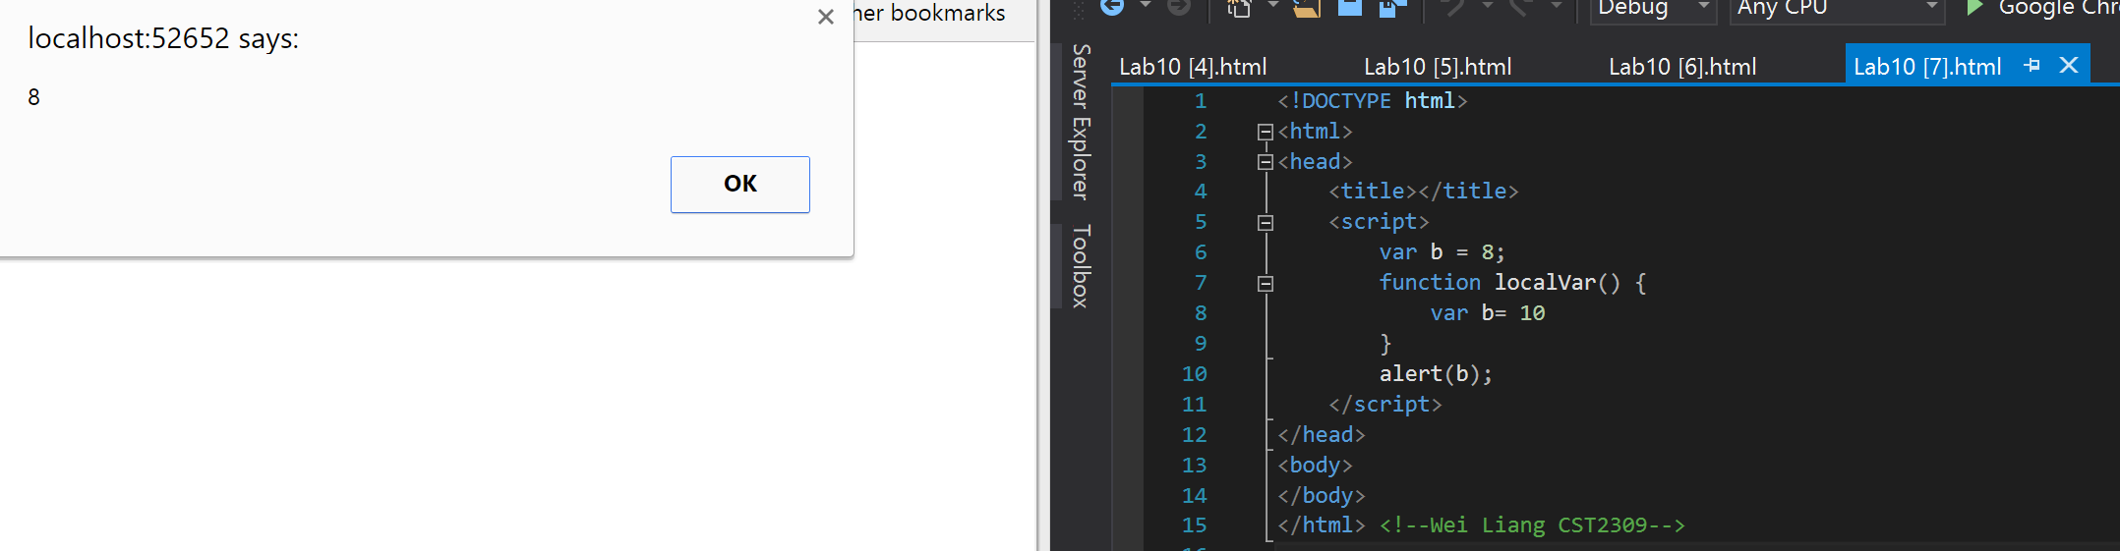

**Question 8:**

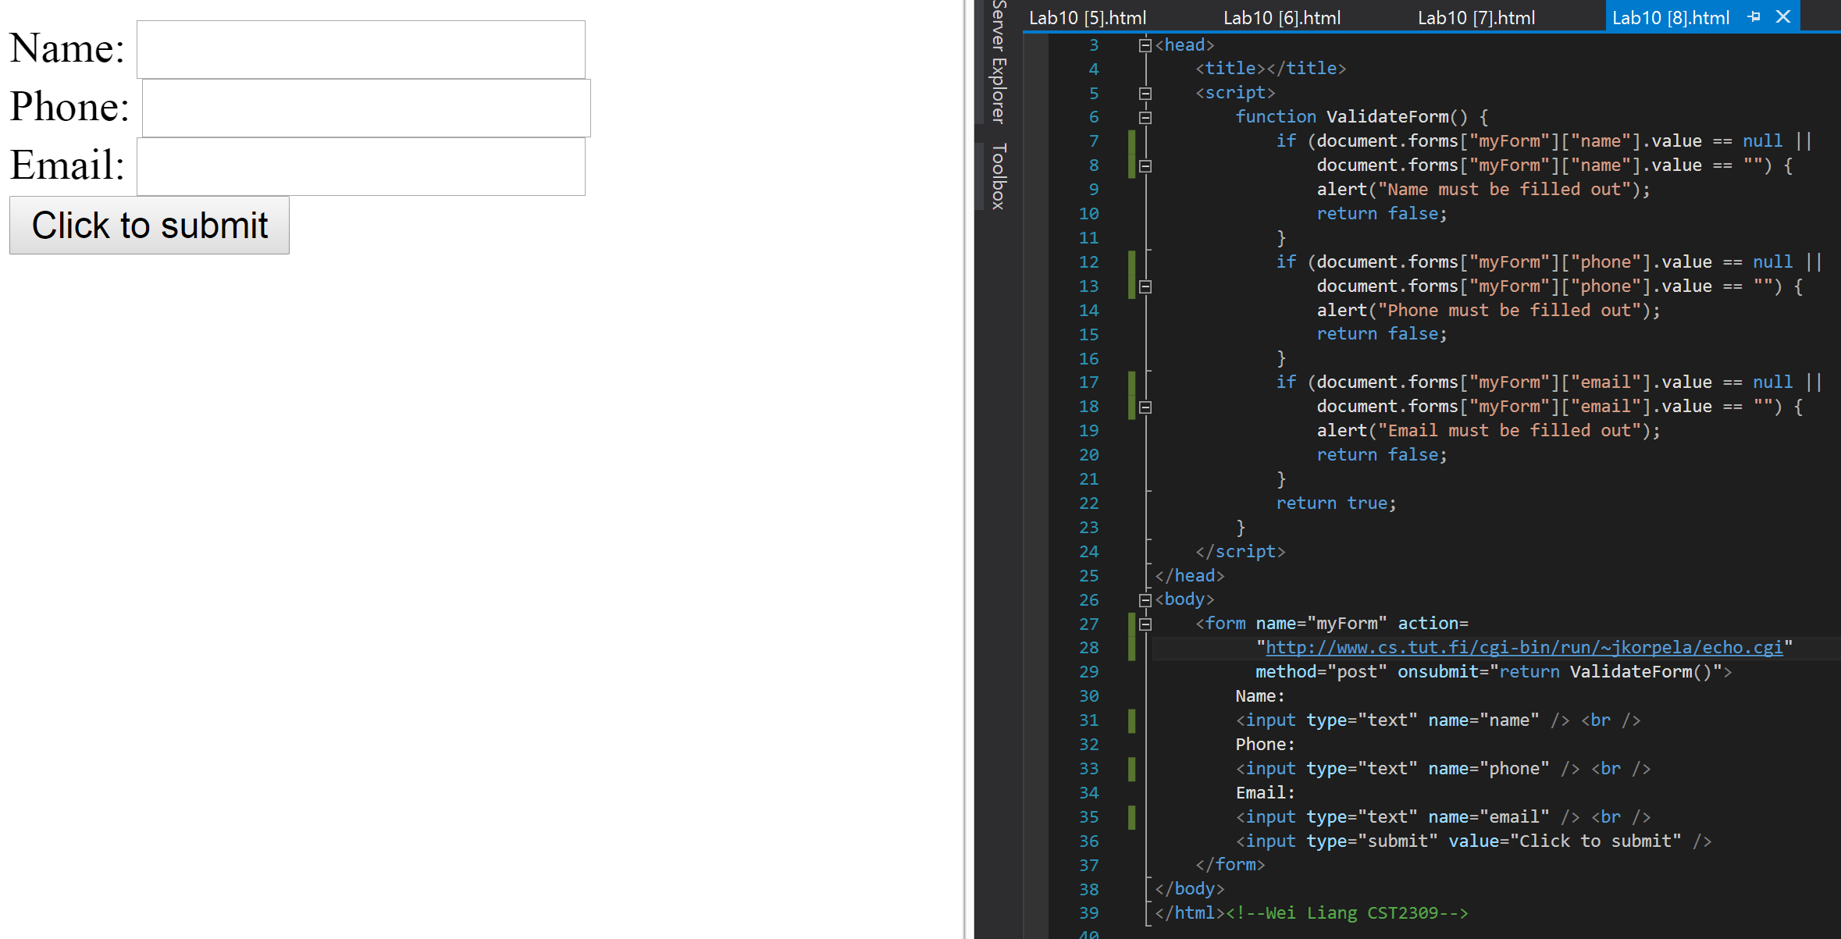

|  |  |
| --- | --- |
| **Nothing filled** | **Only Name filled out:** |
| **Email unfilled:** | **Everything filled out:** |

**Question 9:**

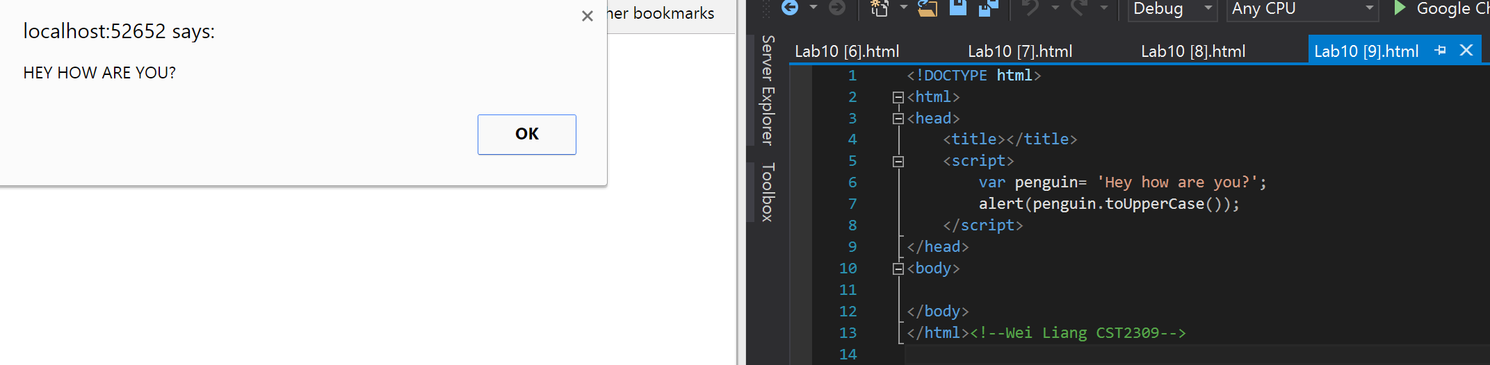

**Question 10:**

